[ Insert official UPAEP logo ]
UPAEP · Decanato de Ingenierías
EVIDENCE — US16-T5
Implement irrigation safety conditions
SmartGreenAI: Cilantro Crop

1. Task information
Task ID | US16-T5
User Story | US-16 — Automatic irrigation according to predefined conditions
Sprint | Sprint 3 (2026-10-12 – 2026-10-30)
Week | Week 2 (carry-over, closed in Week 3)
Responsible | Oscar Abraham Talavera Nava
Peer reviewer | Vicente Rocha Alfaro
Planned / actual hours | 2 h / 2.5 h (variance recorded in the Sprint 3 burndown)
Completed on | October 26, 2026
Status | Done

2. Task description
Block automatic irrigation during cooldown, when the water tank is below the minimum level (creates an alert) and when the soil sensor has not sent data for 5 minutes.

3. Completion conditions
✓ Condition 1: Cooldown is respected.
How it was verified: Cooldown respected: right after the irrigation of US16-T4, with the soil below the minimum, the engine decision is "SKIP" — Soil moisture is 58.0 %; 2 consecutive readings below 60 % are required.
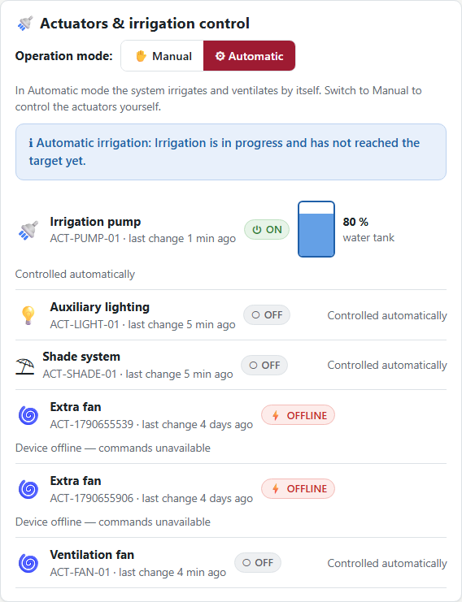
Figure US16-T5-1. Cooldown: "Soil moisture is 58.0 %; 2 consecutive readings below 60 % are required." (US16-T5_Implement_Irrigation_Safety_Conditions_1.png)
Engine decision (GET /api/irrigation/status/AREA-1)
{
"action": "SKIP",
"reason": "Soil moisture is 58.0 %; 2 consecutive readings below 60 % are required.",
"current_moisture": 58
}

✓ Condition 2: Low tank blocks irrigation and generates an alert.
How it was verified: Low tank (15 %) blocks irrigation — decision "BLOCK_LOW_WATER": The water tank is at 15 %, below the minimum of 20 % required to irrigate. The engine raised a HIGH LOW_WATER alert and created no command (0 commands in the last minute).
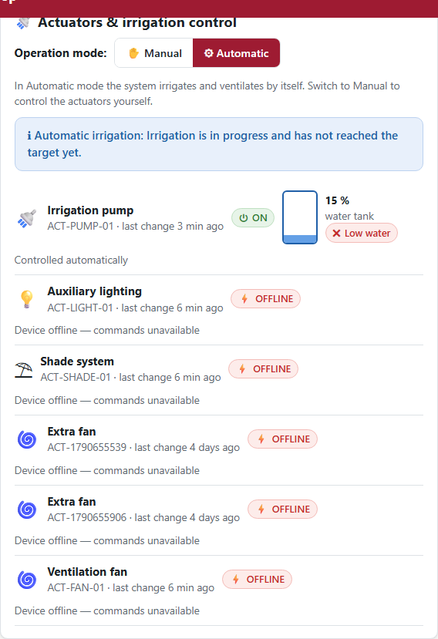
Figure US16-T5-2. Low water tank: "The water tank is at 15 %, below the minimum of 20 % required to irrigate." (US16-T5_Implement_Irrigation_Safety_Conditions_2.png)
LOW_WATER alert created by the engine (1 rows; US16-T5_Implement_Irrigation_Safety_Conditions_3.csv)
id | type | severity | status | value | message | created_at
alr-99df2ee30f60 | LOW_WATER | HIGH | OPEN | 15 | The water tank is at 15 %, below the minimum of 20 % requ… | 2026-09-29T04:47:00.264Z
SQL: SELECT id, type, severity, status, value, message, created_at FROM alerts WHERE type = 'LOW_WATER' ORDER BY created_at DESC LIMIT 1
✓ Condition 3: Stale sensor data blocks irrigation.
How it was verified: Stale sensor data blocks irrigation: after more than 5 minutes without soil readings the decision is "SKIP" — The soil sensors have not reported for 6 minutes; irrigation is blocked for safety.
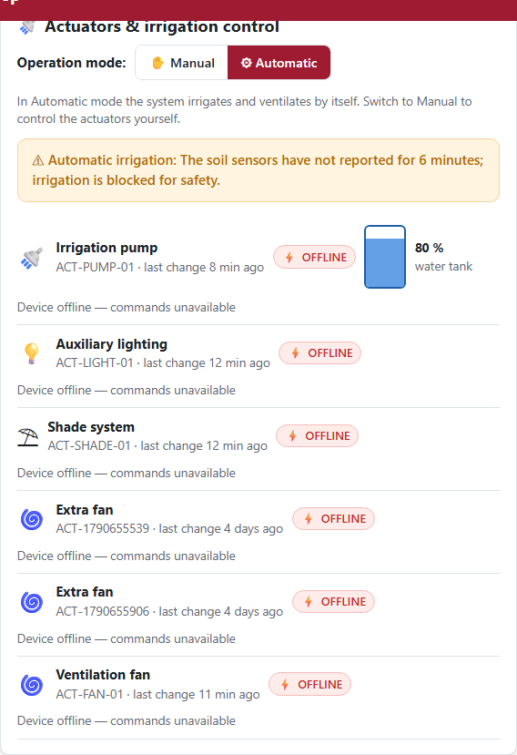
Figure US16-T5-3. Stale sensor data: "The soil sensors have not reported for 6 minutes; irrigation is blocked for safety." (US16-T5_Implement_Irrigation_Safety_Conditions_5.png)
Engine decision
{
"action": "SKIP",
"reason": "The soil sensors have not reported for 6 minutes; irrigation is blocked for safety.",
"blocked": true,
"safety": "STALE_SENSOR",
"actuator_id": "ACT-PUMP-01"
}

✓ Condition 4: Evidence: Log and screenshots of every blocked case.
How it was verified: Log and screenshots of every blocked case. The parameters shortened for the demonstration (cooldown) were restored to 30 minutes; the area was returned to MANUAL mode.
Engine log of the blocked cases (1 rows; US16-T5_Implement_Irrigation_Safety_Conditions_6.csv)
created_at | level | message
2026-09-29T04:47:00.270Z | WARN | Irrigation blocked in AREA-1: The water tank is at 15 %, …
SQL: SELECT created_at, level, message FROM system_logs WHERE source = 'automationEngine' AND message LIKE '%blocked%' ORDER BY created_at DESC LIMIT 8
server/src/modules/irrigation/service.js — lines 149–208
// --- Safety: stale sensor data (US16-T5) --------------------------------
const newest = await db.one(
`SELECT MAX(m.recorded_at) AS at
FROM measurements m JOIN sensors s ON s.id = m.sensor_id
WHERE s.area_id = $1 AND s.type = 'soil_moisture' AND s.is_active`,
[area.id],
);
const ageMinutes = newest && newest.at ? (Date.now() - new Date(newest.at).getTime()) / 60000 : Infinity;
if (ageMinutes > STALE_MINUTES) {
return skip(`The soil sensors have not reported for ${Math.round(ageMinutes)} minutes; irrigation is blocked for safety.`,
{ blocked: true, safety: 'STALE_SENSOR', actuator_id: pump.id });
}
const currentMoisture = averages[0].avg_value;
// --- Stop condition: the pump is running and reached the target ---------
if (pump.state === 'ON') {
if (currentMoisture >= Number(config.target_moisture)) {
return {
action: 'OFF',
actuator_id: pump.id,
reason: `Soil moisture reached the target of ${config.target_moisture} % (currently ${currentMoisture.toFixed(1)} %).`,
current_moisture: currentMoisture,
};
}
// Maximum duration reached: the device auto-stops, but the engine also
// sends an explicit OFF so the state converges if the timer was missed.
const startedAt = await lastIrrigationAt(area.id);
if (startedAt && (Date.now() - startedAt.getTime()) / 60000 >= Number(config.max_duration_min)) {
return {
action: 'OFF',
… (28 more lines)

4. Attached files
- US16-T5_Implement_Irrigation_Safety_Conditions_1.png
- US16-T5_Implement_Irrigation_Safety_Conditions_2.png
- US16-T5_Implement_Irrigation_Safety_Conditions_3.csv
- US16-T5_Implement_Irrigation_Safety_Conditions_4.sql
- US16-T5_Implement_Irrigation_Safety_Conditions_5.png
- US16-T5_Implement_Irrigation_Safety_Conditions_6.csv
- US16-T5_Implement_Irrigation_Safety_Conditions_7.sql

5. Traceability
Related requirements | FR-18, NFR-08
Implementation | decide(): cooldown, tank < minimum → BLOCK_LOW_WATER + LOW_WATER alert, stale sensor > 5 min, fault readings excluded, MANUAL mode, command in flight
Verification | integration/irrigation.test.js › US16-T4 safety rules

6. Sign-off
Role | Name | Date | Signature
Responsible | Oscar Abraham Talavera Nava | October 26, 2026
Peer reviewer | Vicente Rocha Alfaro | October 26, 2026
Product Owner acceptance | Alexis Enrique Valle Parra | October 26, 2026
Approval record: Daily Meeting 3 of Sprint 3 (Monday, October 26, 2026), team update, Oscar Abraham Talavera Nava: "Finish US16-T5 with Vicente and upload the evidence"; decision: "Feature freeze as soon as US16-T5 is in Ready (today)."

